14.75: a) Consider the fluid in the horizontal part of the tube. This fluid, with mass 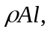 is subject to a net force due to the pressure difference between the ends of the tube, which is the difference between the gauge pressures at the bottoms of the ends of the tubes. This difference is 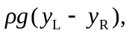 and the net force on the horizontal part of the fluid is

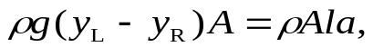

or

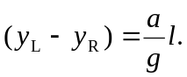

b) Again consider the fluid in the horizontal part of the tube. As in part (a), the fluid is accelerating; the center of mass has a radial acceleration of magnitude 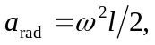 and so the difference in heights between the columns is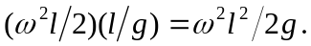

Anticipating Problem, 14.77, an equivalent way to do part (b) is to break the fluid in the horizontal part of the tube into elements of thickness dr; the pressure difference between the sides of this piece is 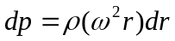 (see Problem 14.78), and integrating from 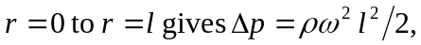 giving the same result.

c) At any point, Newton’s second law gives 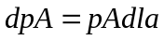from which the area A cancels out. Therefore the cross-sectional area does not affect the result, even if it varies. Integrating the above result from 0 to l gives 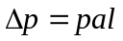 between the ends. This is related to the height of the columns through 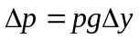 from which p cancels out.

